AWS SES

AWS SES(simple Email Service) is an email platform that provides an easy, cost-effective way for you to send and receive email using your own email addresses and domains.
Simple Email Service is one of the very popular and highly scale-able service, used by thousands of businesses and developers across the globe. Some of the notable businesses are HBO, Siemens, Careem etc. Recently got a chance to work on it and I found it very convenient and easy to setup. The combined power of other amazon services (like SNS, SQS, Lambda) with AWS SES makes it work like a charm and fit to your business needs as required.

Open AWS Management Console

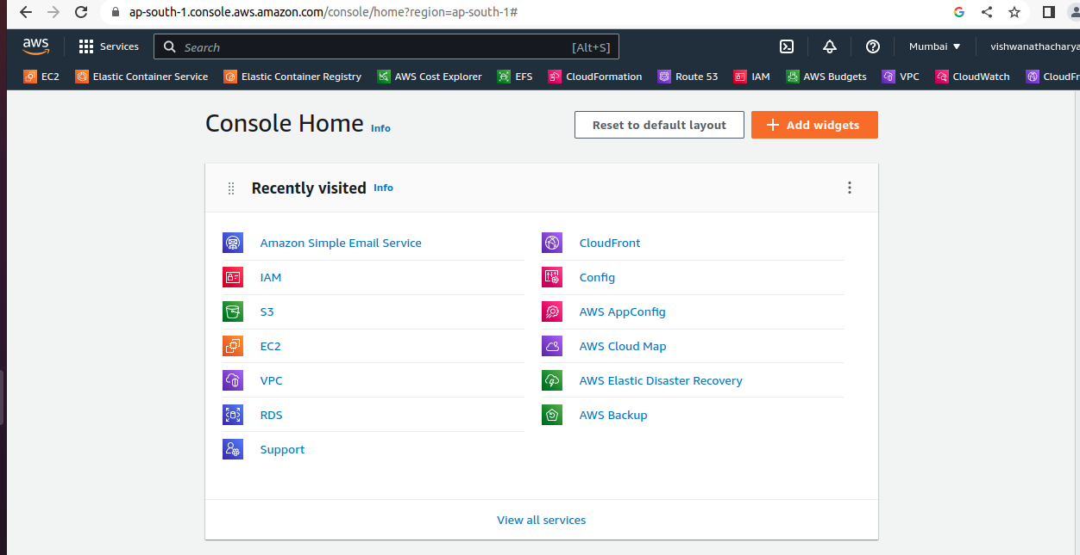
Search SES Service
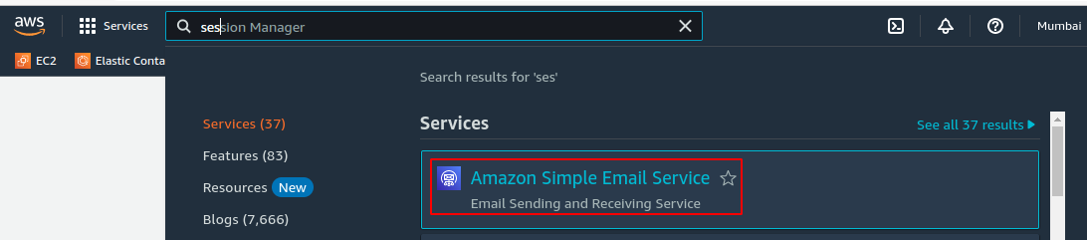
Open SES Service
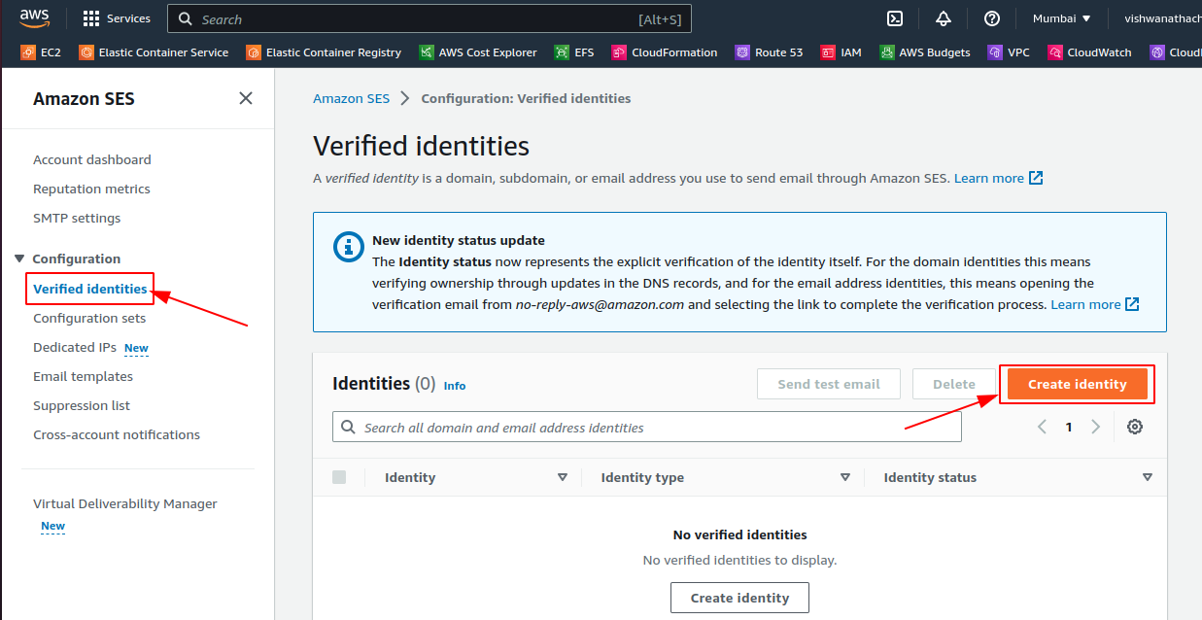
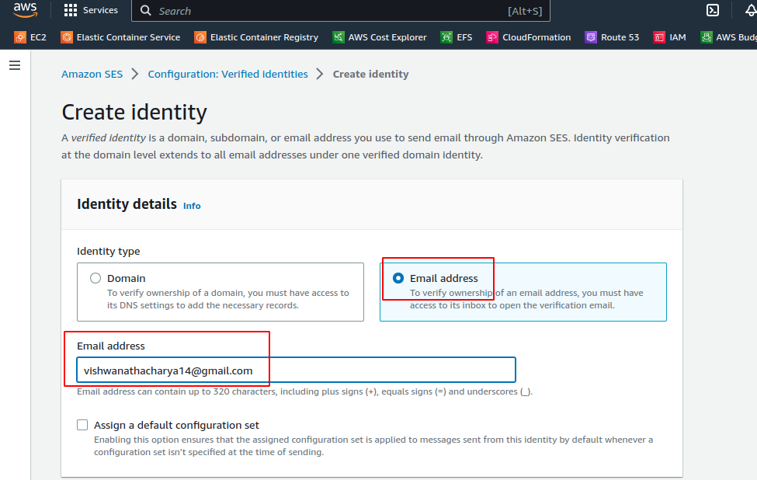
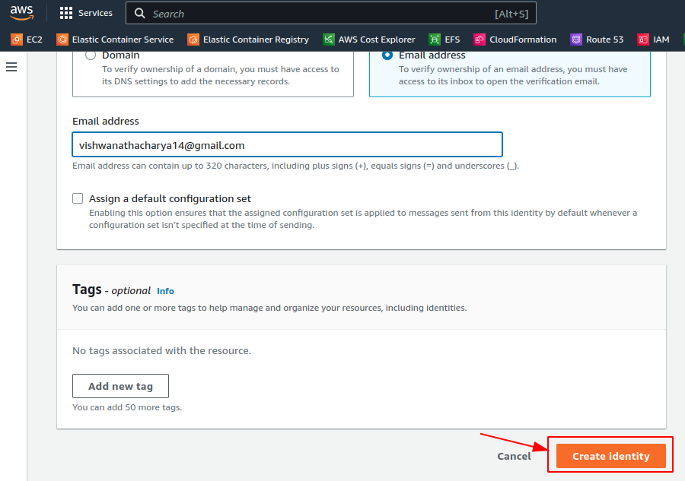
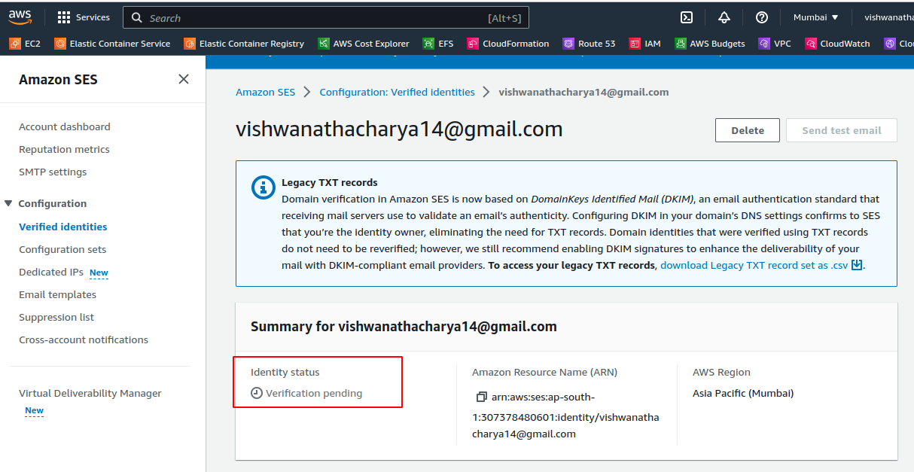
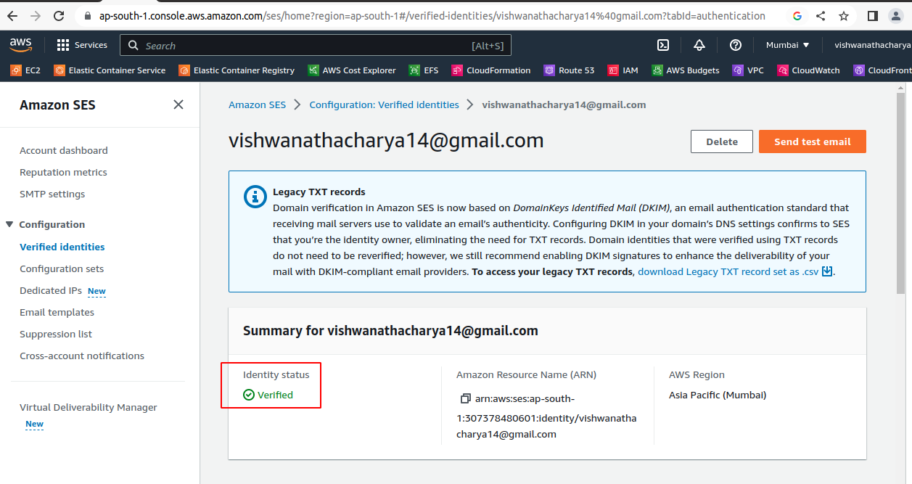
open your email check & confirm
Create another Identitie
